Joints: How can you injure them?
Introduction icebreakers
- Do you know what joint this is?
- Do you know what movement(s) this joint is meant to make?
- Can you move your joint like that?
- Do you want to work out what injuries the people in these scenarios have?
Injuries of the knee joint
- Osteoarthritis
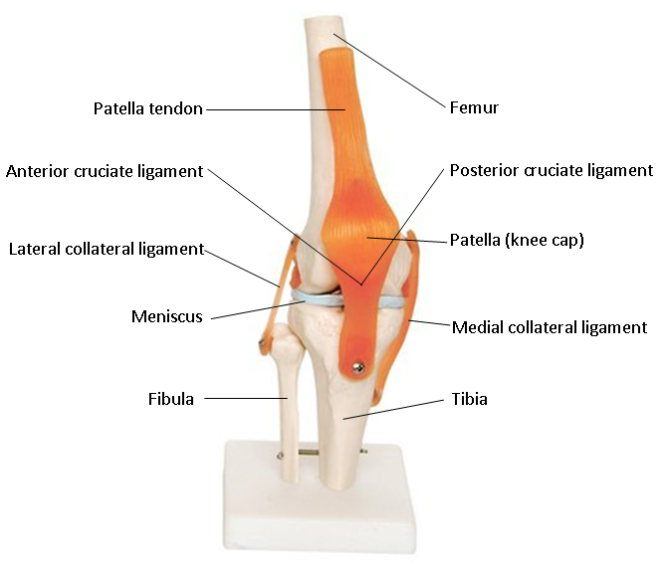
- Anterior Cruciate Ligament

Osteoarthritis
Osteoarthritis is a chronic degradation of cartilage. It is more common in middle-older age or following trauma injuries to the knees.
Role of cartilage
Cartilage lines the ends of long bones such as the tibia and femur in the knee. It helps the smooth movement of the knee and provides some protection to the ends of the bones.
How can the damage occur?
The damage to cartilage can occur over a long time, but it can be speeded up by doing high impact exercise or following knee injuries.
Recognition
Mild inflammation of the tissues in and around the joints, damage to cartilage, the strong, smooth surface that lines the bones and allows joints to move easily and without friction and bony growths that develop around the edge of the joints.
Scenario
Peter hasn’t played squash for 10 years. He had to give up a while ago as he was getting a lot of knee pain after playing. However, his colleague David has challenged him to a game, so he is going to play again. After 20 minutes of playing squash Peter has to stop. His knees are hurting and although he can walk it is a bit painful to do so.
- What do you think is wrong with Peter’s knees?
- Do you think his injury has occurred suddenly or has got worse over time?
Anterior Cruciate Ligament
Anterior cruciate ligament (ACL) injuries can be incredibly debilitating. The ACL is located inside the knee joint between the tibia and femur. It works with the posterior cruciate ligament to give stability to the knee.
Recognition
Pain on attempting to move the knee, swelling at the knee joint and sometimes a popping sound is heard by the individual when the rupture occurs.
How can the damage occur?
The anterior cruciate ligament (ACL) can be fully torn (ruptured) by direct blows to the knee or violent twists. This can occur through high-impact sports such as volleyball, basketball and squash. In football ACL injuries generally occur by two mechanisms either high impact to the side of the knee or through a quick change of direction where the foot remains planted in the same place and the knee and rest of the body twists in another direction.
Scenario
Jenny was playing volleyball and jumped up to spike the ball into the opponent’s court. When Jenny landed from her powerful spike she violently twisted her knee and fell to the floor gripping her knee in agonising pain. She thought she heard a popping sound as she landed and found it very hard to put any weight on her knee. After a short time Jenny’s knee began to swell up around the joint.
- Can you demonstrate the twisting movement on the model of the knee?
- What part of her knee do you think she has damaged?

Treatment
ACL ruptures can be treated by physiotherapy or a combination of surgery and physiotherapy. Stability and strength in your glutes, hamstrings, core and quadriceps can aid the stability of your knees, as can correct technique when playing sports. If a surgical intervention is required a graft can be taken from the patella tendon or the hamstring tendon and it replaces the ruptured ACL in the knee by drilling holes in the tibia and femur for the ACL to be attached to. Following surgery a strict physiotherapy programme must be followed to build up the muscles and stability of the knee. An ACL injury usually takes an athlete 6-9 months to get back to playing sport.
Injuries of the ankle joint
- Sprained ankle
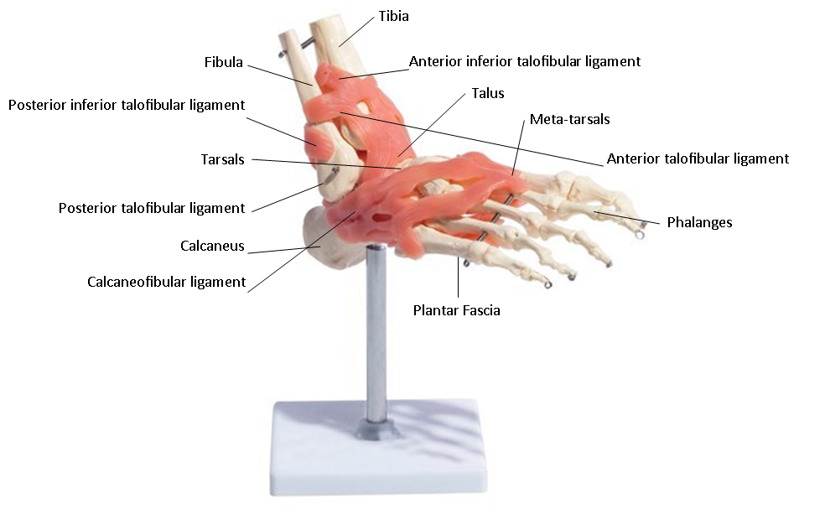
- Fractured meta-tarsal

Sprained ankle
This is due to overstretching or tearing of a ligament in the ankle. This could be due to a sudden or unexpected wrenching motion that pulls the bones in the joint too far apart and tears the surrounding tissues.
Recognition
Pain and tenderness, difficulty in moving the injured part, especially if it is a joint, swelling and bruising in the area.
Scenario
Susan was jogging along an uneven woodland path admiring the beautiful scenery as she ran. She did not notice the tree root in front of her which she stepped on and lost her footing.
- What do you think Susan has done to her ankle?
- What part of her ankle may she have damaged?

Fractured meta-tarsal
David Beckham and Wayne Rooney famously suffered from meta-tarsal fractures.
Recognition
Difficulty in walking, stiffness of movement, bruising and swelling, deformity. Minor fractures are usually caused by direct force and multiple fractures, affecting many or all of the bones in the foot are usually caused by crushing injuries.
Scenario
David was playing football. His opponent Wayne went to tackle him, missed the ball and stamped on David’s foot with his studded boot. David screamed in pain and fell to the floor grabbing his foot.

- What injury do you think he could have?
- What part of his foot do you think he has damaged?

Injuries of the shoulder joint
- Dislocated shoulder
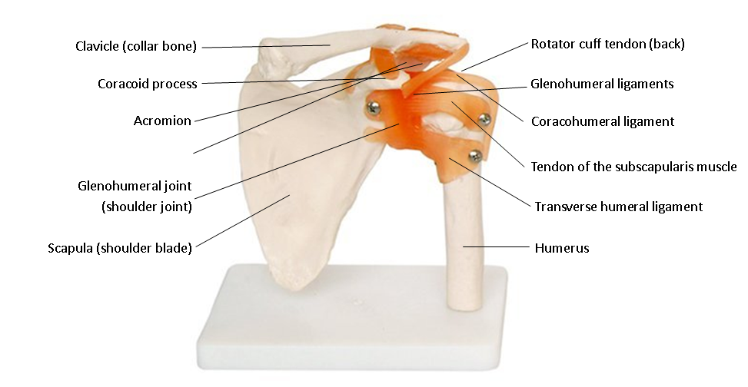
- Torn rotator cuff

Dislocated shoulder
Shoulder joint injury where bones are partially or completely pulled out of the normal position. Forward and downward dislocations are most common. Dislocation of the shoulder can occur from a strong force wrenching the bone (humerus) into an abnormal position or by a violent muscle contraction. Dislocation of the shoulder may damage the large nerves that supply the arm so it is important that it is treated quickly by trained professionals.
Recognition
‘Sickening’ severe pain, inability to move the joint, swelling and bruising around the affected joint, shortening, bending or deformity of the area

Scenario
Tim was playing tennis with Tom. The game was close and in the fifth set Tim had match point. He wanted to win the game with an ace serve so with all his strength he hit the tennis ball as hard as he could. On the final impact of the racket on the tennis ball Tim felt a severe pain in his shoulder and dropped his racket immediately. He couldn’t move his arm as it was very painful.
- Can you model the movement of a tennis serve on the shoulder joint model?
- What do you think Tim has done to his shoulder?

Torn rotator cuff
Rotator cuff tears are most common in people over 40. The muscles between the neck and shoulder tend to compensate for the lack of movement of the rotator cuff muscles, which can result in a hunching of the shoulder.
Recognition
Difficulty in raising your arm properly, especially above shoulder height and there may be some pain.
Scenario
Rachel was about to play her weekly game of badminton with her friends Nigel, Derek and Sarah. But as they were warming up Rachel realised she didn’t have much movement in her arm and couldn’t lift it above her shoulder.
- How high can you lift your arm?
- What part of Rachel’s shoulder do you think she has damaged?

